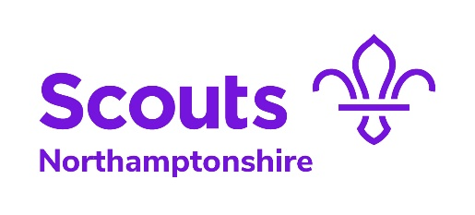
Personal learning plan template
Data Privacy Statement: This form is used to collect information about you for the purpose of recording training progression, this is to be used by us at the Scouts. We do not share your personal data provided in this forms with any third parties. We take your personal data privacy seriously. The data you provide to us is securely stored in a membership database. For further detail please visit our Data Protection Policy here. We will keep the data we capture from this form for only as long as necessary before it is transferred onto the membership database. For further detail on our retention periods please visit our Data Protection Policy here.
Name: |  | Appointment: |  | Membership number:
Group: |  | District: |  | County/Region/Area: |  | Training adviser:
Intial plan agreed (date): |  | Plan reviewed (date): |  | Date provisional appointment ends: |  | Sheet: |  | of

Are you able to take part in training held at the weekends? Yes No

Are you able to take part in training held in the evenings? Yes No If so, please state your availability: Mon Tue Wed Thur Fri

Module number | Learning required Y/N | Proposed learning method | Planned completion date | Actual completion date | Validation methods | Planned validation completion date | Validation completion date | Training Adviser signature

Personal learning plan agreed by – Learner: Training Adviser:
A copy of the learning plan should be sent to the appropriate Training Manager after each review of the plan and any updates.

Name: |  | Appointment: |  | Membership number: |  | Sheet: |  | of

Module number | Learning required Y/N | Proposed learning method | Planned completion date | Actual completion date | Validation methods | Planned validation completion date | Validation completion date | Training Adviser signature

Personal learning plan agreed by – Learner: Training Adviser:
Additional sheets should be copied and attached to the front sheet.

