
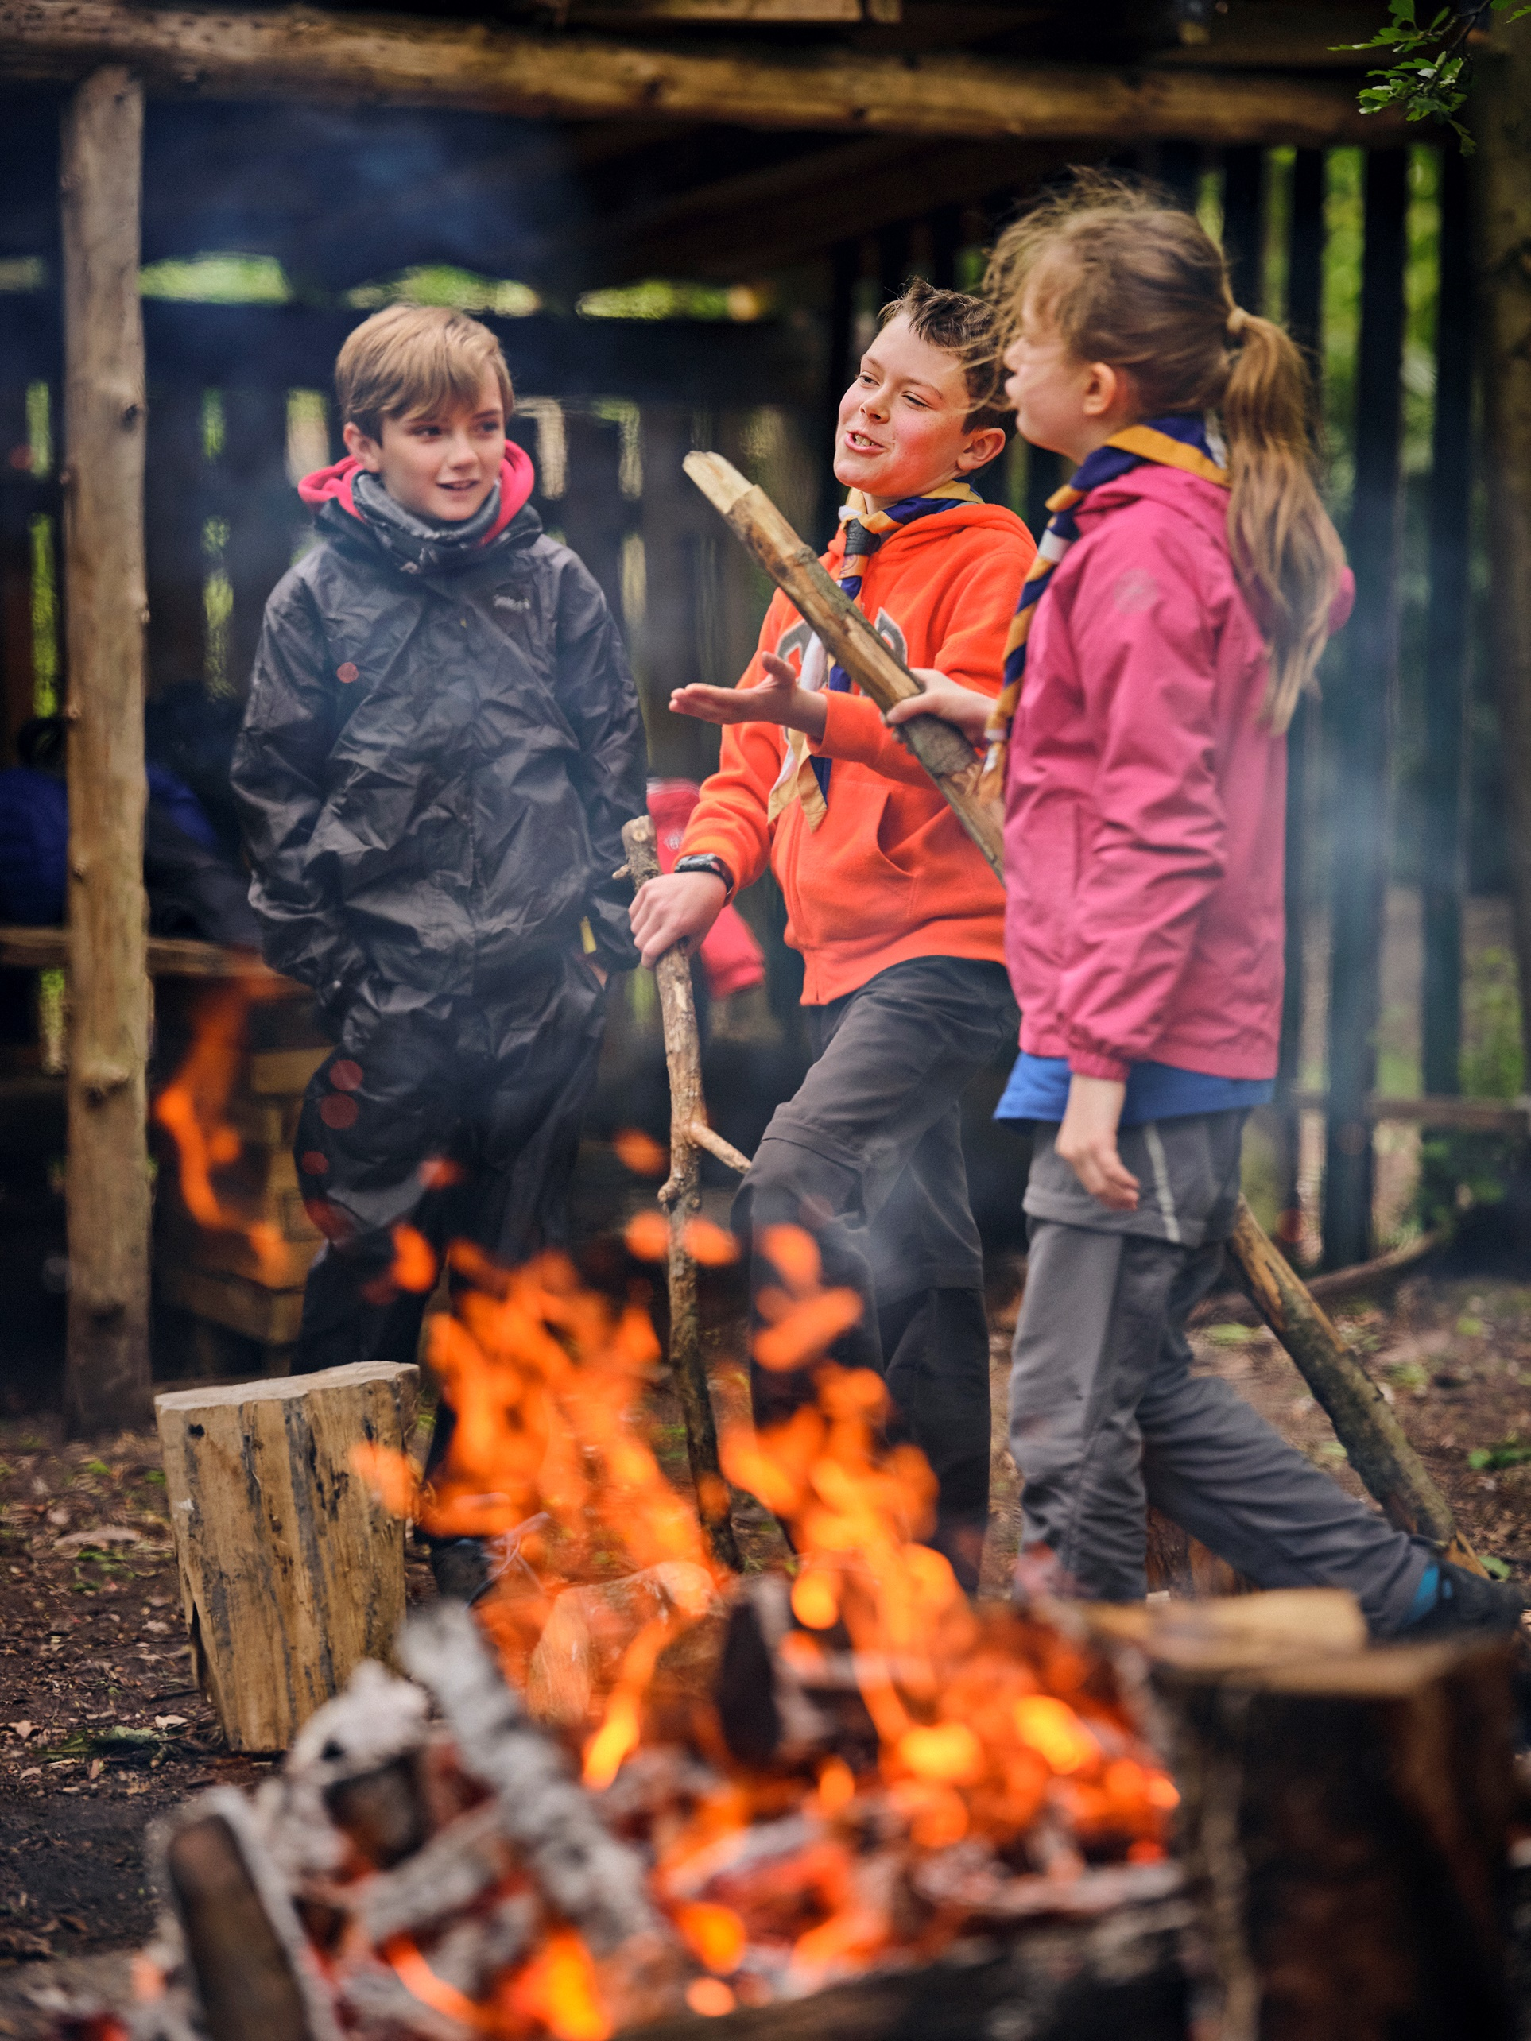
County Commissioner
Volunteer Vacancy Pack

Lead and shape the future of Scouting in Northamptonshire

Contents
Lead and shape the future of Scouting in Northamptonshire 1
Contents 2
Introduction to the England Team 3
How to apply or nominate someone 4
Why would I want to volunteer as a County Commissioner in Scouts? 5
The role - County Commissioner 6
Northamptonshire Scouts 8
The current vacancy 8
Core Skill Areas 9
Person specification 10
Induction for new County Commissioners 11
More information about Scouts 11

Introduction to the England Team
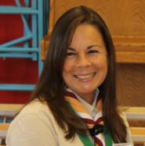
It is an exciting time to be involved in Scouting, as we develop and progress our Skills for Life strategy, in order to prepare better futures and deliver skills for life to young people who want to access Scouting.

The County Commissioner role is an important UK Headquarters appointment within the England Team, responsible for providing inspirational and effective leadership for one of the 60 English Counties. As County Commissioner you will take the lead for implementing our 2018-25 strategy with your team of District Commissioners and ensuring they feel motivated and supported to lead the Scout Groups in their Districts to success.
Liz Henderson, Chief Commissioner of England

The England Team is broad and also includes our staff colleagues within the Growth and Communities Team, the eight Regional Commissioners, our regional growth and training leads and the new core volunteer teams (Support, Programme and Volunteer Development). You will be joining a team of talented, focused volunteers who are all passionate about bringing brilliant Scouting to every young person who wants to take part.

The role of County Commissioner is a demanding one, but we believe that it is critical to our success as well as being a highly rewarding challenge for the right volunteer. We are looking for individuals who can lead and inspire their team by being a great coach, critical friend and motivator. This is a senior manager role within Scouts and comes with significant responsibilities. It also offers a unique opportunity to make a real impact on the lives of young people in your County through building, nurturing and leading a team to deliver our shared vision. This role provides the opportunity to be at forefront of our continued success within England Scouting.

If you’re not convinced yet, check out page 5 where we have asked some of the team to explain why they enjoy being a County Commissioner so much.

How to apply or nominate someone

Process
Thank you for your interest in volunteering as County Commissioner within the England Leadership Team. On the following pages you will find more information about the role, as well as what the team is all about and what’s in it for you as a volunteer joining us.

You can apply for the role yourself using the application form, or nominate someone else using the nomination form. Nominated people are under no commitment to apply unless they wish to. Apply or nominate online:

Apply yourself | Nominate someone else

A search group has been put together to oversee this process and will review all applications and nominations in order to make decisions as to who to invite to attend the selection stage of this process.

Key dates
The closing date for applications is midnight on Wednesday 7th June

Interview dates: Monday 19th June

Further information
For more information, or for an informal chat about this vacancy, please contact:
Paula Evans - Regional Commissioner, East Midlands
Email: Paula.Evans@scouts.org.uk
or
Niki Cody - Growth and Communities Manager (Midlands)
Email: Nicola.Cody@scouts.org.uk / Phone: 07779433928

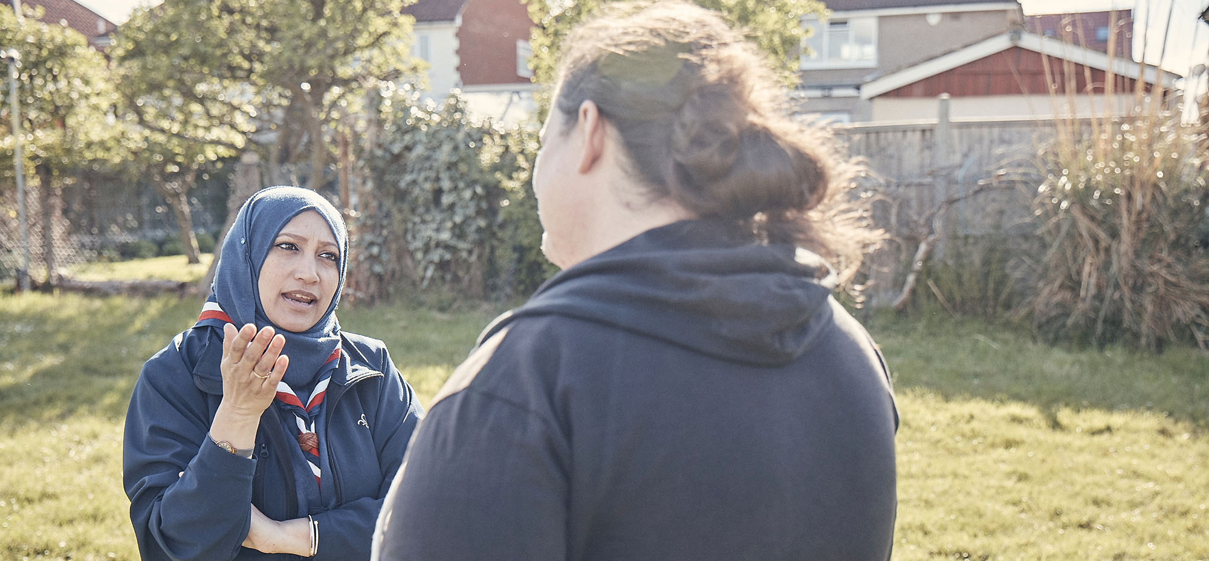

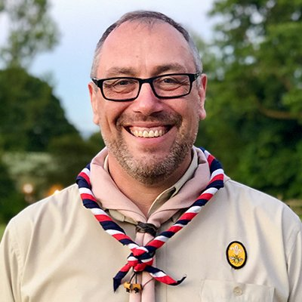
Why would I want to volunteer as a County Commissioner in Scouts?

So what’s in it for me you’re wondering? Whilst volunteering as a County Commissioner can be challenging at times, it is also incredibly rewarding and here’s why, according to our current team of County Commissioners in the England Team…
As a County Commissioner you will be able to really develop and hone your leadership skills by managing teams of remote volunteers across the breadth of Northamptonshire. Leading and managing volunteers provides so much more opportunity and experiences than with employees, what you can gain by doing this really well can be a great asset for your professional life as well as in Scouts. The issues and challenges that you find ways to tackle will stretch you as an individual and as a leader and you’ll find yourself discovering new things that you are capable of achieving.

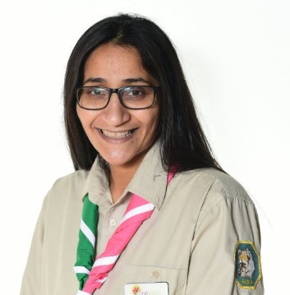
This role is all about people and one of the incredible benefits of volunteering in any role in Scouts, but even more so as County Commissioner, is the teams of people you get to work with. You will inherit an incredible team of dedicated people leading Scouting in Northamptonshire, from District Commissioners who manage Scouting on a local level, to the people delivering high quality training for our Scout Leaders. As County Commissioner you get to inspire, motivate, shape and develop this team, building friendships and establishing a sense of camaraderie focused around our mission for young people.

If you get a kick out of seeing things happen, achieving success and making a positive impact to a wide audience then the County Commissioner role definitely provides all of that. In this role you will get to see the difference that Scouts makes to so many young people’s lives across a large area, helping them developing skills for life, fostering friendships and providing so many incredible and unforgettable experiences.

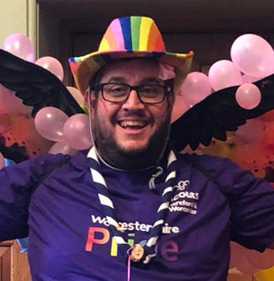
As a County Commissioner you have an important role to lead the progress of our strategy. One such element of our strategy where County Commissioners play a leading role is in the provision of our Scouting programme to those harder to reach communities and groups of young people who might not normally have the option to take part. It will be your role to help lead our efforts to do this in Northamptonshire. It is an exciting time to take up the reins and support this work to achieve our ambitious goals for new young people.

And if you’re reading this thinking that it all sounds quite exciting and something you’d quite enjoy doing, but maybe you’re worried about the timing or you might think there is someone else who would be better for the role, ask yourself if not me, then who? If not now, then when?

The role - County Commissioner
Outline:
The County Commissioner is a key volunteer leadership role within Scouting with responsibility for providing outstanding management and support for the six Districts within the County. The primary focus for the County Commissioner is to ensure that Scouting is able to reach every young person in the County; open to all regardless of faith, colour or social background, because we believe Scouting has the ability to change lives. This is achieved by leading the team of six District Commissioners, and other County appointments as well as working with the Growth and Communities Team (employed staff) to provide enough places to meet the demand for Scouting, and by ensuring that every youth member has access to a high-quality balanced programme that is challenging, relevant and rewarding.

Appointed by: | Regional Commissioner for East Midlands, England, via a search group process responsible to the UK Headquarters Appointments Advisory Committee
Responsible to: | Regional Commissioner for East Midlands, England
Responsible for: | District Commissioners, Deputy County Commissioners, Assistant County Commissioners, County Training Manager, Youth Commissioner, Transformation Lead and all other County appointments, however it is expected that line management for other roles are delegated to Deputies/Assistants.
Main contacts: | Deputy County Commissioners, Assistant County Commissioners, County Chairman, County Network Scout Commissioner, members of the County Trustee Board and its subcommittees, District Commissioners, County Training Manager, County Scout Active Support Managers, members of the Growth and Communities Team, other County Commissioners in the Region, Chief Commissioners of England, members of the local community, schools and other youth organisations in the County.
Key tasks: | - Ensure that every Squirrel Drey, Beaver Scout Colony, Cub Scout Pack, Scout Troop, Explorer Scout Unit and Scout Network within the County is able to deliver a high-quality programme which is challenging, relevant and rewarding for every young person  - Provide proactive line management, including coaching, mentoring and guidance to District Commissioners as well as other adult volunteers in the County who directly report to you including setting objectives for their work, holding regular one-to-one meetings and reviews.  - Build and maintain a sense of County team by holding regular team meetings with the District Commissioners, Deputy and Assistant County Commissioners, County Training Manager and other appropriate volunteers within your County team to collaborate and provide peer support.  - Lead a safe, open and transparent culture around keeping young people and adults safe through our Yellow Card and key policies.  - Ensure the timely recruitment and appointment of new District Commissioners where required and ensuring that interim arrangements are put in place for any vacant posts.  - Together with the District Commissioners, agree the priorities for the County and produce a plan to deliver these to meet The Scout Association’s vision and strategic objectives.  - Ensure that problems within the County are resolved so that an effective volunteering culture is encouraged and District Commissioners and Group Scout Leaders feel supported to deal with challenging issues, including complaints in a timely manner.  - Ensure that the County has an adequate team of supported and appropriate adults working effectively together and with others to meet the Scouting needs of the area.  - Ensure that problems within the County are resolved so that excellent Scouting is provided to young people in the County.  - Act as an ex-officio trustee as a member of the County Trustee Board, and an ex-officio member of the Council of The Scout Association.  - Play an active part within the East Midlands, England regional team by attending up to 3x meetings per year for County Commissioners, led by the Regional Commissioner and twice yearly England Team meetings for all County Commissioners to contribute to the development of Scouting within England as part of the Headquarters team.
Appointment requirements: | - County Commissioners are required to validate the learning for our manager and supporter volunteer training scheme, completion of which is recognised through the achievement of a Wood Badge for the County Commissioner role. As a key leadership position within Scouts we expect new County Commissioners to set a strong example and complete this required training within their first year.  - County Commissioners must be eligible for charity trustee status (as a member of the County Trustee Board).  - It is expected that whilst volunteering for this role you will undertake regulated activity.  - County Commissioners are also expected to actively contribute as a member of their regional team and England Team, this includes attending between three to six regional team meetings and two All England Team meetings per year. As an ex-officio member of the Council of The Scout Association, County Commissioners are expected to vote on matters presented to Council including elect trustees to the Board and attend the Annual General Meeting, usually held on the first weekend in September.
Terms of appointment: | The initial length of appointment is at the discretion of the Regional Commissioner, through discussion with the appointee, and is usually for a period of one to three years initially before a formal appointment review. County Commissioners may complete no more than a total of ten years in the role. Renewal and continuation of appointment is at the discretion of the Regional Commissioner and appointment reviews may be conducted at any time at the request of the role-holder and/or Regional Commissioner.

Note: Many of the tasks for which the County Commissioner is responsible may be delegated to others in the County, including a Deputy County Commissioner, if appointed. Whilst the new appointee will inherit an existing team of volunteers in key County appointments, it is expected that new County Commissioners will review and reorganise their team’s objectives and roles as they see fit.

For more information about the role
Interested candidates are also encouraged to review Factsheet FS330074 available online at: County/Area roles | Scouts which provides more information about the role of the County Commissioner, structured around the six key areas of leadership and management.


Northamptonshire Scouts
In Northamptonshire County, there are 6 Districts, made up of 114 Groups. This covers Daventry and District, Glendon, Grafton, Nene Valley, Northampton and Wellingborough Districts. Northamptonshire Scouts’ total membership is currently 7,697 which includes:
- 161 Squirrels (4 - 6 year olds)
- 1,492 Beaver Scouts (6 - 8 year olds)
- 1,856 Cub Scouts (8 - 10 ½ year olds)
- 1,580 Scouts (10 ½ - 14 year olds)
- 475 Explorer Scouts (14 – 18 year olds)
- 177 Network members (18 – 25 year olds)
- 1,956 Adult Volunteers (18+ year olds)

The current vacancy
We’re currently looking for a County Commissioner. This is a management role, and we need someone who can provide leadership, motivation and guidance to our other adult volunteers.

The management structure of Scouting is as follows:

County Commissioners support volunteers and other managers, known as District Commissioners, who in turn support the managers of local Scout Groups. Adults at every level need support to ensure that they are motivated, inspired and focused on providing first-class Scouting. A good manager thanks other volunteers for their hard work, and helps to make sure that they feel happy and supported, week after week.

The County Commissioner will also provide direction for the County, and will help others see the bigger Scouting picture through solid leadership.

We believe that everyone in management roles within Scouting should adopt an approach that combines the skills of both leadership and management.

In Northamptonshire, there are several key tasks and activities which are carried out by the County Commissioner and county’s volunteer leadership team which would form part of the role and fall within the new County Commissioner’s scope to review, adapt and delegate accordingly. Some of these are carried out by the current County Commissioner and some are delegated to Deputy or Assistant County Commissioners. The important point here is that we don’t expect the County Commissioner to be a super-hero and do all of this, or devote every hour of the day to the role. You will have the support of a sound Trustee Board and the existing county team.

Core Skill Areas

We’ve identified six core skill areas that make a good Scouting manager:

1. Providing direction
A good County Commissioner will create a vision for Scouting in their County, and provide clear leadership to implement that vision.

2. Working with people
It is vital that a County Commissioner can create team spirit amongst the other volunteers they work with, and can form effective working relationships based on trust and the fundamental principles of Scouting:
- integrity
- respect
- care
- belief
- cooperation

3. Achieving results
Good County Commissioners ensure that goals are achieved, plans are seen through to completion, and that good relationships are maintained within and between Scouting Districts. Forging links within the local community is also an important aspect of development.

4. Enabling change
It is important for County Commissioners to encourage volunteers to think of creative ways to improve Scouting across the County. They should then provide the support to implement appropriate changes.

5. Using resources
A good County Commissioner will ensure that information and resources are available, helping volunteers across the County to continue to provide excellent Scouting opportunities to young people.

6. Managing time and personal skills
A good County Commissioner should use their time effectively, and be willing to continue to learn and improve their skills.

Person specification

Knowledge and experience:
Ability to lead, manage and motivate people in a voluntary environment. | Essential
Understanding of the challenges of working in the voluntary sector | Desirable
Experience of working with young people and/or community work with adult groups | Desirable
Experience of volunteering in a manager/supporter role in Scouting (e.g. Group Scout Leader, District Commissioner or other District/County role) | Desirable

Skills and abilities:
Excellent ability to communicate effectively, orally and in writing including ability to speak and present publicly in a clear, articulate and motivating way | Essential
Ability to provide advice and guidance effectively to others | Essential
Ability to provide inspirational strategic leadership for the County | Essential
Ability to contribute to strategy development and identify practical actions to achieve strategic objectives. | Essential
Ability to effectively chair meetings. | Essential
Can build, maintain and facilitate effective working relationships with a wide range of people | Essential
Ability to enable others to identify issues, clarify objectives, develop attainable objectives and gain the necessary skills and confidence to work as an effective team | Essential
Ability to negotiate compromises | Essential
Plans, manages and monitors own tasks and time | Essential
Can construct and implement long-term plans that improve and expand the Scouting offered to young people, and identify any training, resources and other needs required to undertake this work. To facilitate the strategic growth of the county | Essential
Ability to use technology, especially mobile email, to carry out a range of tasks (confident in Microsoft Word, Excel and PowerPoint). | Essential

Personal qualities:
An understanding of the needs of adult volunteers | Essential
Flexible approach | Essential
Self-motivated | Essential
Able to work as part of a team and promote good teamwork | Essential
Resourceful, energetic and enthusiastic about the job | Essential
Acceptance of the fundamentals of the Scout Movement | Essential

Induction for new County Commissioners
Induction plan delivered by the Growth and Communities Team
New County Commissioners will receive a series of face to face and remote interactions with the Growth and Communities Manager, in conjunction with the Regional Commissioner, as part of a structured induction for the role. These interactions will also include an opportunity to develop a plan of action in the role with dedicated support from staff within the Growth and Communities Team to implement actions around developing and growing Scouting in the County.

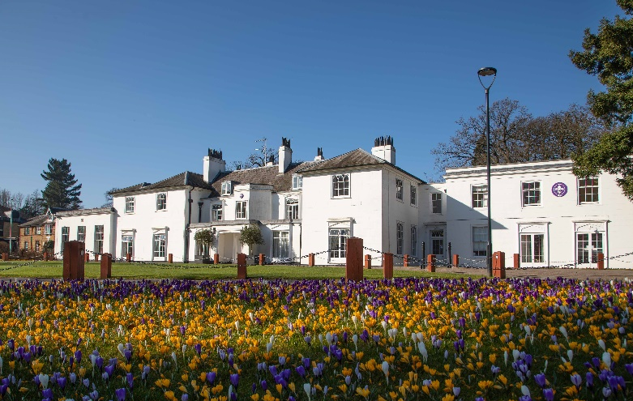
Headquarters Volunteer Induction Days
County Commissioners are appointed by UK Headquarters to lead Scouting in their assigned County, and as such are a key part of the Headquarters Team, working in partnership with staff colleagues employed by the national charity, who are responsible for managing a range of nationally delivered services for local Scouting. New County Commissioners are invited to attend a two-day Headquarters induction at The Scouts’ national headquarters at Gilwell Park, London where you will have the chance to meet with key staff colleagues to put faces to names and explore the support available to you as part of the wider Headquarters team.

The Growth and Communities Team
The Growth and Communities Team is part of the UK Headquarters staff team within the Volunteering Operations Department, with field-based staff who cover the eight English regions. Teams of Growth and Recruitment Officers, Local Growth Operations Managers and Growth and Communities Managers work alongside Group Scout Leaders, District, County and Regional Commissioners, as well as Assistant Regional Commissioners (Growth) to help open new sections, units and groups, provide tools to help existing groups to grow, provide training on adult recruitment, and support the induction of new volunteer managers in Scouting.

The Regional Commissioner is a key link between the Growth and Communities Team and local Scouting. Through close working and effective communication, the Regional Commissioner will develop plans with you and the other County Commissioners in the team to ensure the best use of resources to achieve Scouting’s goals for the region, as agreed with the Chief Commissioner of England. One Growth and Communities Manager manages the staff team for both the East and West Midlands regions and works closely with both Regional Commissioners. The Growth and Communities Manager is line managed by the Head of Member Support England.

More information about Scouts
Click on the links below to read more about Scouts, our key policies and our Skills for Life strategy to 2025
- What Scouts do
- Skills for Life – our strategy to 2025
- About volunteering with Scouts
- Our rules and key policies

